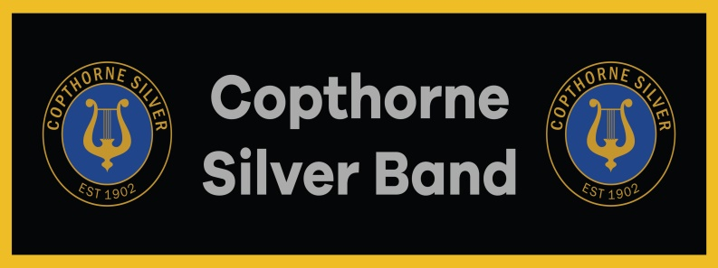 Newsletter No 12 January 2022

*‘ When it is obvious that goals cannot be reached, don’t adjust the goals;*

*adjust the action steps.’* anonymous

On behalf of the Band Committee I hope you all had a good Christmas and wish you every happiness in this New Year.

Band rehearsals start again this Thursday 6th January and we look forward to seeing you there.

After a busier than expected lead up to Christmas, we look forward to a brighter and better New Year with more opportunities for the Band to play.

The committee members and Chris have been busy over Christmas sorting out the music pads, removing some of the numbers we have ‘played to death’ over the last 2 years and introducing some new music. More will be added in coming weeks but we need to ensure that it is issued with care so that all the parts are in all the pads. With Rays departure the Band does not have a designate librarian and it even more essential that every member takes responsibility for their music.

There are a couple pads that were not returned before Christmas and we would ask that these are brought in as soon as possible so that the music in these pads can sorted.

A list of the music that is in the pads now is included with this e-mail.

The committee want to try and take every opportunity this year to increase our membership, maintain a good profile and look to encouraging brass playing with young people as well as providing a good standard of performance at our engagements. A tall order, in difficult times, with a committee that is quite small and lacking a treasurer and librarian. We shall be looking for volunteers for these roles in the coming months.

The support shown by members during the Christmas engagements, which provided much pleasure to many, demonstrates a determination by all the members that we will see this Covid issue through all its challenges.

However, as we move into 2022 Covid (Omicron) remains an issue which we must live with:

We continue to monitor advice from Making Music and Brass Band England.

They both list 6 priority actions for band rehearsals.

1. **Complete a health and safety risk assessment that includes risks from COVID-19.**

Our risk assessment has been updated and includes the following provisions:-

Social distancing is not a legal requirement but we are advising members to maintain a 1m distance and to respect those who prefer to have a greater distance.

Should any member wish to have screening, they are available and will be positioned as required.

All reference to handling to limiting the handling of chairs, music and equipment is removed, but members are asked to use the hand sanitiser as they enter the building, and ensure that they have cloths to keep the area around themselves clean.

It is now again a legal requirement that **masks** are worn in all community halls, **at all times other than when playing** unless the member has exemption.

Tea breaks will continue but please try to respect each other needs regarding social distancing.

1. **Turn people with COVID-19 symptoms away.**

We do not want to have to have the embarrassment of turning people away although we must if it is necessary. We would ask members not to attend if they have any symptoms:-

According to ZOE data scientists, the top five **Omicron symptoms** to watch out for are:

* Runny nose
* Headache
* Fatigue (mild or severe)
* Sneezing
* Sore throat

The NHS states that **cold symptoms** come on more gradually and these can include:

* A blocked or runny nose
* A sore throat
* Headaches
* Muscle aches
* Coughs
* Sneezing
* A raised temperature
* Pressure in your ears and face
* Loss of taste and smell

These lists are very similar in content and many will recognise symptoms which they endure as a matter course.

Our advice is that if you suffer any **new symptoms** from either of the above lists you should take a lateral flow test before you attend rehearsal. It is not a legal requirement for gatherings of less than 500 people but we want to protect each other.

We will continue to take temperatures on arrival.

1. **Provide adequate ventilation.**

Whilst it is better than playing outside this is going to be more difficult during the colder months. Keeping some windows open is necessary but we do have the benefit of the extract fans if we can tolerate the noise.

With the underfloor heating you should have warm feet but we advise that you come dressed in warm clothing and respect those who seek more ventilation.

1. **Clean more often.**

The hall is still advising all users to be extra vigilant on cleaning and the general hall cleaning is exceptional thoroughout.

We are now a very small committee and any help wiping down surfaces at the end of rehearsal will be welcomed.

1. **Enable people to check in at your venue to track any infections.**

The NHS QR code is displayed at the door which can be used but we will continue to keep a register of all members attending. Should you test positive for Covid following a rehearsal please advise Sheila so that other attendees can be notified and seek tests if they wish.

1. **Communicate and train.**

That is the purpose of this letter. We want to keep you informed to let all members know that will listen to any comments they may have in regard to our Covid protection or any other matters.

COPTHORNE SIVER BAND COMMITTEE. JANUARY 2022

**Please let the committee know your comments and views**

****Try the link. https://copthornesilverband.co.uk